Model Optimization and Tuning Phase Template

Date | 15 March 2024
Team ID | 739890
Project Title | Bookmate: A Chatbot Companion For Book Recommendations
Maximum Marks | 10 Marks

Model Optimization and Tuning Phase
The Model Optimization and Tuning Phase involves refining neural network models for peak performance. It includes optimized model code, fine-tuning hyperparameters, comparing performance metrics, and justifying the final model selection for enhanced predictive accuracy and efficiency.

Hyperparameter Tuning Documentation (8 Marks):
Model | Tuned Hyperparameters
Rasa NLU Model | Rasa NLU is a robust natural language understanding (NLU) framework designed to power intelligent chatbots and virtual assistants. It excels at accurately recognizing user intents and extracting relevant entities from textual inputs. By leveraging advanced machine learning techniques, Rasa NLU enables the creation of sophisticated conversational AI systems that can understand and respond to user queries in a natural and intuitive manner.  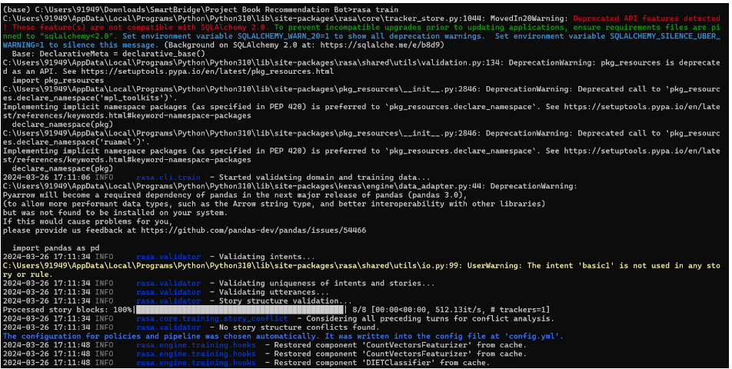
Deep Learning Model (e.g., RNN, Transformer) | Deep learning models, particularly Recurrent Neural Networks (RNNs) and Transformers, have revolutionized the field of book recommendation systems. RNNs are well-suited for sequential data, making them ideal for capturing user reading history and preferences. Transformers, on the other hand, excel at capturing long-range dependencies in text data, enabling a deeper understanding of book descriptions and user queries. By combining the strengths of these models, we can build sophisticated recommendation systems that provide highly accurate and personalized book suggestions.  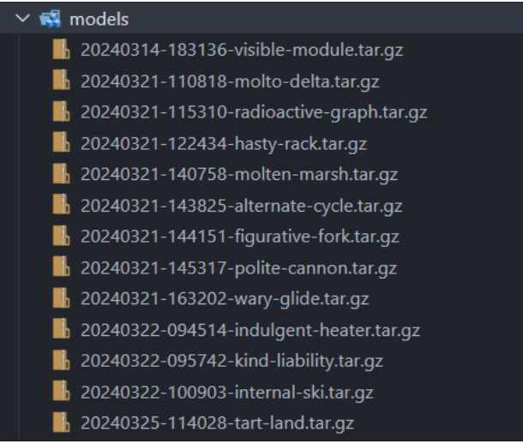

Final Model Selection Justification (2 Marks):
Final Model | Reasoning
Rasa NLU Model | Rasa NLU is a powerful tool for building intelligent chatbots and virtual assistants. It excels at understanding natural language, identifying user intent, and extracting relevant information from user queries. For a book recommendation chatbot, Rasa NLU can be used to accurately interpret user requests, such as "Recommend a sci-fi book with a strong female protagonist," and extract relevant entities like "sci-fi" and "strong female protagonist."  One of the key advantages of Rasa NLU is its flexibility. You can customize the NLU pipeline to fit your specific needs, including defining custom intents and entities. This allows you to tailor the chatbot to understand the nuances of book recommendations, such as preferences for genres, authors, or reading moods.  